Brainstorm

& idea prioritization

### Use this template in your own brainstorming sessions so your team can unleash their imagination and start shaping concepts even if you're not sitting in the same room.

**10 minutes** to prepare

**1 hour** to collaborate

**2-8 people** recommended

**Before you collaborate**

A little bit of preparation goes a long way with this session. Here’s what you need to do to get going.

**10 minutes**

1. **Team gathering**

Define who should participate in the session and send an invite. Share relevant information or pre-work ahead.

1. **Set the goal**

Think about the problem you'll be focusing on solving in the brainstorming session.

1. **Learn how to use the facilitation tools**

Use the Facilitation Superpowers to run a happy and productive session.

[**Open article**](https://support.mural.co/en/articles/2113740-facilitation-superpowers)

**1**

## Define your problem statement

What problem are you trying to solve? Frame your problem as a How Might We statement. This will be the focus of your brainstorm.

**5 minutes**

**PROBLEM**

## Swimming pools are generally places of fun and a healthy exercise,but can also prove to be deadly as well.Even with a lifeguard observer on duty,swimmers may still have trouble in underwater

#### Key rules of brainstorming

To run an smooth and productive session

**2**

## Brainstorm

Write down any ideas that come to mind that address your problem statement.

**10 minutes**

**MOHAN SAI PK**

Detect victims

Vision-based survellance system to monitor swimmers

**ANAND PRINCE PURTY**

Check medical condition before swimming

Real-Time image processing to track swimmers in swimming pools

**MUDUNURI SAI KRISHNAM RAJU**

**TIP**

You can select a sticky note and hit the pencil [switch to sketch] icon to start drawing!

# 

Using YOLO object detection to detect whether a person is drowning or not

Alarm to notify lifeguard

**PRASANNA VENKAT A**

Resuce people by sending lifeguard

Infra-red technology can be used to monitor drowning people

**3**

## Group ideas

Take turns sharing your ideas while clustering similar or related notes as you go. Once all sticky notes have been grouped, give each cluster a sentence-like label. If a cluster is bigger than six sticky notes, try and see if you and break it up into smaller sub-groups.

**20 minutes**

# Using Cloud Technology

Automatic alarm to notify lifeguard

Check the medical condition before swimming

Check the authenticity of swimmers before allowing them to swim in pool

Using Python/Deep Learning

**4**

## Prioritize

Your team should all be on the same page about what's important moving forward. Place your ideas on this grid to determine which ideas are important and which are feasible.

**20 minutes**

Check the authenticity of swimmers before alowing them to swim in pool

Real-Time image Processing to track swimmers in swimming pools

Vision-based surveillance system to monitor swimmers

**TIP**

Add customizable tags to sticky notes to make it easier to find, browse, organize, and categorize important ideas as themes within your mural.

## After you collaborate

You can export the mural as an image or pdf to share with members of your company who might find it helpful.

#### Quick add-ons

1. **Share the mural**

**Share a view link** to the mural with stakeholders to keep them in the loop about the outcomes of the session.

1. **Export the mural**

Export a copy of the mural as a PNG or PDF to attach to emails, include in slides, or save in your drive.

#### Keep moving forward

**Strategy blueprint**

Define the components of a new idea or strategy.

[**Open the template**](https://app.mural.co/template/e95f612a-f72a-4772-bc48-545aaa04e0c9/984865a6-0a96-4472-a48d-47639307b3ca)

**Customer experience journey map**

Understand customer needs, motivations, and

Stay in topic. Defer judgment.

By using Underwater cameras can watch the movements of vivictims

Infra-red technology can be used to monitor drowning people

Encourage wild ideas. Listen to others.

# Using YOLO

#### Importance

Location tracking for identifying drowning people

If each of these

obstacles for an experience.

[**Open the template**](https://app.mural.co/template/b7114010-3a67-4d63-a51d-6f2cedc9633f/c1b465ab-57af-4624-8faf-ebb312edc0eb)

By using Underwater cameras can watch the movements of vivictims

Check the medical condition before swimming

Go for volume. If possible, be visual.

tasks could get

done without any difficulty or cost, which would have the most positive impact?

Real-Time image Processing to track swimmers in swimming pools

Using YOLO object detection it can detect whether a person is drowning or it's a normal person

Vision-based surveillance system to monitor swimmers

**Strengths, weaknesses, opportunities & threats**

Identify strengths, weaknesses, opportunities, and threats (SWOT) to develop a plan.

|  |  |
| --- | --- |
|  |  |
|  |  |

[**Open the template**](https://app.mural.co/template/6a062671-89ee-4b76-9409-2603d8b098be/ca270343-1d54-4952-9d8c-fbc303ffd0f2)

[**Share template feedback**](https://muralco.typeform.com/to/CiqaHVat?typeform-source=app.mural.co)

By using Underwater cameras can watch the movements of vivictims

[**Share template feedback**](https://muralco.typeform.com/to/CiqaHVat?typeform-source=app.mural.co)

#### Feasibility

Regardless of their importance, which tasks are more feasible than others? (Cost, time, effort, complexity, etc.)

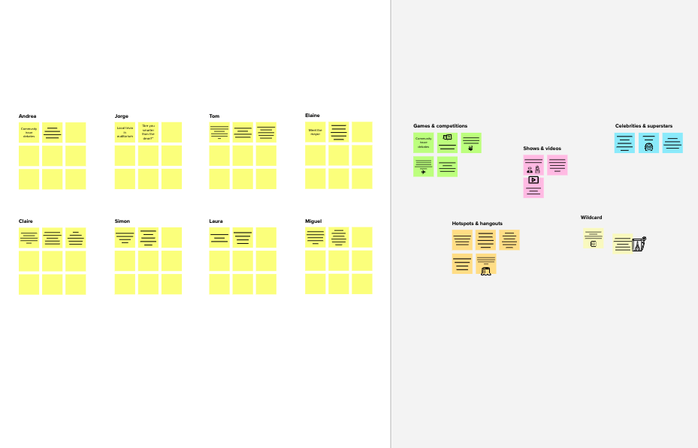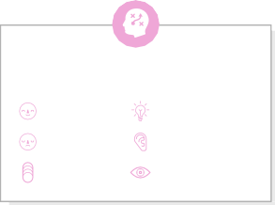

**Template**

**Need some inspiration?**

See a finished version of this template to kickstart your work.

[**Open example**](https://app.mural.co/template/e5a93b7b-49f2-48c9-afd7-a635d860eba6/93f1b98d-b2d2-4695-8e85-7e9c0d2fd9b9)